- Test Case
**UPI Test Cases**

1. **TC_UPI_001**: Successful fund transfer using UPI with valid beneficiary details and sufficient balance.
* Preconditions: User has a valid UPI ID, beneficiary has a valid UPI ID, and user has sufficient balance.
* Steps: User initiates fund transfer using UPI, enters beneficiary's UPI ID, and confirms the transaction.
* Expected Result: Fund transfer is successful, and the beneficiary receives the amount.
2. **TC_UPI_002**: Fund transfer using UPI with valid beneficiary details and insufficient balance.
* Preconditions: User has a valid UPI ID, beneficiary has a valid UPI ID, but user has insufficient balance.
* Steps: User initiates fund transfer using UPI, enters beneficiary's UPI ID, and confirms the transaction.
* Expected Result: Fund transfer fails due to insufficient balance, and an error message is displayed.
3. **TC_UPI_003**: Successful fund transfer using UPI with multiple beneficiaries.
* Preconditions: User has a valid UPI ID, multiple beneficiaries have valid UPI IDs, and user has sufficient balance.
* Steps: User initiates fund transfer using UPI, enters multiple beneficiaries' UPI IDs, and confirms the transaction.
* Expected Result: Fund transfer is successful, and all beneficiaries receive the amount.
4. **TC_UPI_004**: Fund transfer using UPI with invalid beneficiary details.
* Preconditions: User has a valid UPI ID, but beneficiary has an invalid UPI ID.
* Steps: User initiates fund transfer using UPI, enters beneficiary's invalid UPI ID, and confirms the transaction.
* Expected Result: Fund transfer fails due to invalid beneficiary details, and an error message is displayed.
5. **TC_UPI_005**: Successful fund transfer using UPI with beneficiary's UPI ID saved in user's address book.
* Preconditions: User has a valid UPI ID, beneficiary has a valid UPI ID saved in user's address book, and user has sufficient balance.
* Steps: User initiates fund transfer using UPI, selects beneficiary's UPI ID from address book, and confirms the transaction.
* Expected Result: Fund transfer is successful, and the beneficiary receives the amount.
6. **TC_UPI_006**: Fund transfer using UPI with user's UPI ID blocked.
* Preconditions: User's UPI ID is blocked, beneficiary has a valid UPI ID.
* Steps: User initiates fund transfer using UPI, enters beneficiary's UPI ID, and confirms the transaction.
* Expected Result: Fund transfer fails due to user's UPI ID being blocked, and an error message is displayed.
7. **TC_UPI_007**: Successful fund transfer using UPI with OTP verification.
* Preconditions: User has a valid UPI ID, beneficiary has a valid UPI ID, and user has sufficient balance.
* Steps: User initiates fund transfer using UPI, enters beneficiary's UPI ID, and confirms the transaction with OTP verification.
* Expected Result: Fund transfer is successful, and the beneficiary receives the amount.
8. **TC_UPI_008**: Fund transfer using UPI with invalid OTP.
* Preconditions: User has a valid UPI ID, beneficiary has a valid UPI ID, and user has sufficient balance.
* Steps: User initiates fund transfer using UPI, enters beneficiary's UPI ID, and confirms the transaction with an invalid OTP.
* Expected Result: Fund transfer fails due to invalid OTP, and an error message is displayed.
9. **TC_UPI_009**: Successful fund transfer using UPI with multiple transactions in a single session.
* Preconditions: User has a valid UPI ID, multiple beneficiaries have valid UPI IDs, and user has sufficient balance.
* Steps: User initiates multiple fund transfers using UPI, enters multiple beneficiaries' UPI IDs, and confirms the transactions.
* Expected Result: All fund transfers are successful, and all beneficiaries receive the amount.
10. **TC_UPI_010**: Fund transfer using UPI with transaction limit exceeded.
* Preconditions: User has a valid UPI ID, beneficiary has a valid UPI ID, but user exceeds the daily transaction limit.
* Steps: User initiates fund transfer using UPI, enters beneficiary's UPI ID, and confirms the transaction.
* Expected Result: Fund transfer fails due to exceeding the daily transaction limit, and an error message is displayed.

**IMPS Test Cases**

1. **TC_IMPS_001**: Successful fund transfer using IMPS with valid beneficiary details and sufficient balance.
* Preconditions: User has a valid account number, beneficiary has a valid account number, and user has sufficient balance.
* Steps: User initiates fund transfer using IMPS, enters beneficiary's account number, and confirms the transaction.
* Expected Result: Fund transfer is successful, and the beneficiary receives the amount.
2. **TC_IMPS_002**: Fund transfer using IMPS with valid beneficiary details and insufficient balance.
* Preconditions: User has a valid account number, beneficiary has a valid account number, but user has insufficient balance.
* Steps: User initiates fund transfer using IMPS, enters beneficiary's account number, and confirms the transaction.
* Expected Result: Fund transfer fails due to insufficient balance, and an error message is displayed.
3. **TC_IMPS_003**: Successful fund transfer using IMPS with multiple beneficiaries.
* Preconditions: User has a valid account number, multiple beneficiaries have valid account numbers, and user has sufficient balance.
* Steps: User initiates fund transfer using IMPS, enters multiple beneficiaries' account numbers, and confirms the transaction.
* Expected Result: Fund transfer is successful, and all beneficiaries receive the amount.
4. **TC_IMPS_004**: Fund transfer using IMPS with invalid beneficiary details.
* Preconditions: User has a valid account number, but beneficiary has an invalid account number.
* Steps: User initiates fund transfer using IMPS, enters beneficiary's invalid account number, and confirms the transaction.
* Expected Result: Fund transfer fails due to invalid beneficiary details, and an error message is displayed.
5. **TC_IMPS_005**: Successful fund transfer using IMPS with beneficiary's account number saved in user's address book.
* Preconditions: User has a valid account number, beneficiary has a valid account number saved in user's address book, and user has sufficient balance.
* Steps: User initiates fund transfer using IMPS, selects beneficiary's account number from address book, and confirms the transaction.
* Expected Result: Fund transfer is successful, and the beneficiary receives the amount.
6. **TC_IMPS_006**: Fund transfer using IMPS with user's account number blocked.
* Preconditions: User's account number is blocked, beneficiary has a valid account number.
* Steps: User initiates fund transfer using IMPS, enters beneficiary's account number, and confirms the transaction.
* Expected Result: Fund transfer fails due to user's account number being blocked, and an error message is displayed.
7. **TC_IMPS_007**: Successful fund transfer using IMPS with OTP verification.
* Preconditions: User has a valid account number, beneficiary has a valid account number, and user has sufficient balance.
* Steps: User initiates fund transfer using IMPS, enters beneficiary's account number, and confirms the transaction with OTP verification.
* Expected Result: Fund transfer is successful, and the beneficiary receives the amount.
8. **TC_IMPS_008**: Fund transfer using IMPS with invalid OTP.
* Preconditions: User has a valid account number, beneficiary has a valid account number, and user has sufficient balance.
* Steps: User initiates fund transfer using IMPS, enters beneficiary's account number, and confirms the transaction with an invalid OTP.
* Expected Result: Fund transfer fails due to invalid OTP, and an error message is displayed.
9. **TC_IMPS_009**: Successful fund transfer using IMPS with multiple transactions in a single session.
* Preconditions: User has a valid account number, multiple beneficiaries have valid account numbers, and user has sufficient balance.
* Steps: User initiates multiple fund transfers using IMPS, enters multiple beneficiaries' account numbers, and confirms the transactions.
* Expected Result: All fund transfers are successful, and all beneficiaries receive the amount.
10. **TC_IMPS_010**: Fund transfer using IMPS with transaction limit exceeded.
* Preconditions: User has a valid account number, beneficiary has a valid account number, but user exceeds the daily transaction limit.
* Steps: User initiates fund transfer using IMPS, enters beneficiary's account number, and confirms the transaction.
* Expected Result: Fund transfer fails due to exceeding the daily transaction limit, and an error message is displayed.

- Image to Text

{
"id": "chatcmpl-47d1b8d3-5af5-4dc1-b670-9af1a4b07f85",
"object": "chat.completion",
"created": 1775750914,
"model": "meta-llama/llama-4-scout-17b-16e-instruct",
"choices": [
{
"index": 0,
"message": {
"role": "assistant",
"content": "RUPOS\nWelcome Back!\nEnter your credentials to access your account.\n\nMobile No\n9876543210\nPassword\n*******\nRemember Me\n\nLogin\n\nBy logging in, you agree to the Terms & Conditions & Privacy Policy\n\nDon't have an account? Book Demo"
},
"logprobs": null,
"finish_reason": "stop"
}
],
"usage": {
"queue_time": 0.663389484,
"prompt_tokens": 2352,
"prompt_time": 0.071880984,
"completion_tokens": 53,
"completion_time": 0.13649664,
"total_tokens": 2405,
"total_time": 0.208377624
},
"usage_breakdown": null,
"system_fingerprint": "fp_37da608fc1",
"x_groq": {
"id": "req_01knsg17j6fs398meeeyreqzd9",
"seed": 1125194936
},
"service_tier": "on_demand"
}

Beautified Content

RUPOS
Welcome Back!
Enter your credentials to access your account.

Mobile No
9876543210
Password
•••••••
☑ Remember Me

Login

By logging in, you agree to the
Terms & Conditions & Privacy Policy
3. Transcription
Hari here, I'm going to run the daily stand up meeting today. We can get started. Morning Hari, morning Sindhu. Radhakrishnan here. So yesterday I've been assigned with a couple of tickets related to balance transfer. So I have written manual test cases initially for that and got it signed off from the BA and PO in our team. and since the latest build is now available in QA, I have started testing those scenarios and monitoring how the system behaves for the different scenarios. So far, the system is good and there are no any defects and if there are any, I will raise it accordingly and once the execution is done, I will focus on converting those steps into automation scripts and see how it goes. So that's the update from my side. Thanks. Thank you Radhakrishnan. Good morning everyone. Sindhu here. Yesterday I have completed smoke and regression testing for the payments module and log3 defects in Jira. And today I will be continuing manual testing for the reports module and automating the transaction history flow in Selenium. and there is no blockers so far and waiting for a new build to proceed with revalidation. So that's all for my update. Thank you. Okay. Thank you, Sindhu. Thank you, guys. Thanks for your update. Thanks, everyone. Thank you.
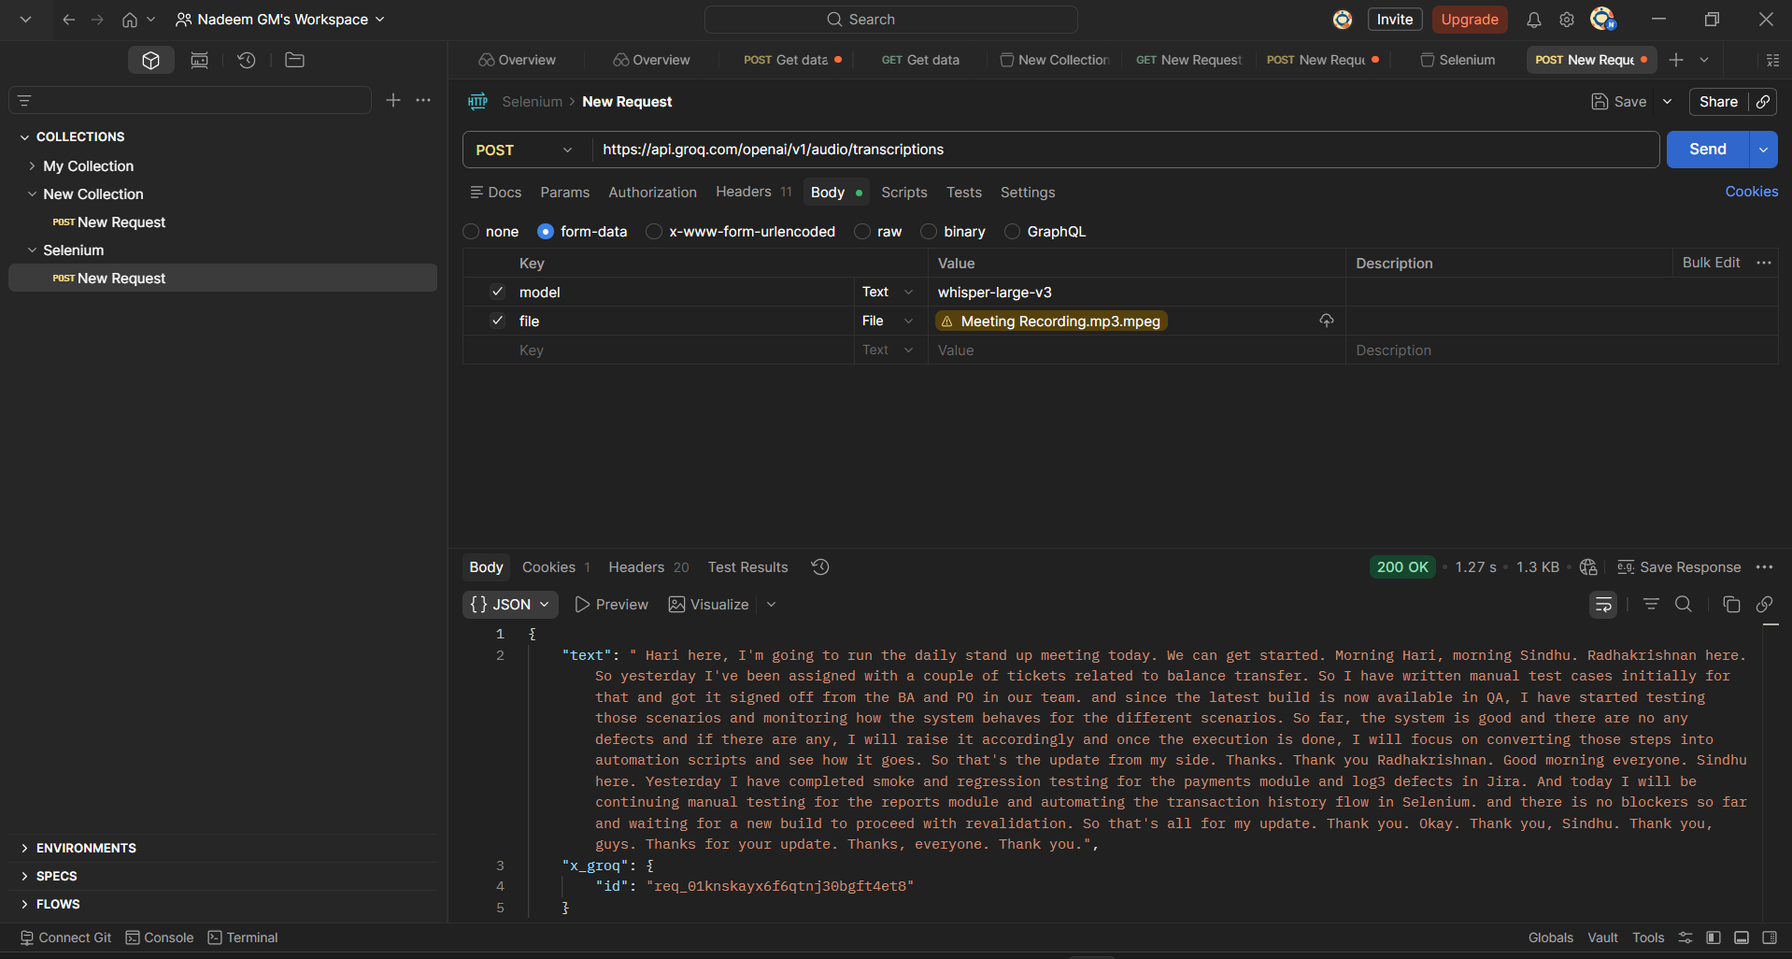
4. Text to Audio

